CARD 9
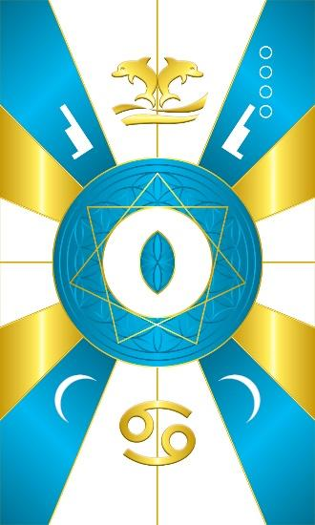
Card 9 represents the energy of Auset/Yemaya. The main colors are Blue & White mixed with some Gold. In the middle is a white circle like that of the Full Moon. It is enveloped by a 7 pointed star. Auset’s sacred number is 7. Within the circle is the almond shaped part of the Vesica Pisces. It symbolizes the yoni and the divine womb, and the gestation of what one wills to manifest. You can see within the yoni the flower of life pattern as the matrix for what is manifested.

Above is the symbol for the constellation of Cancer. Below are dolphins jumping out of a body of water to which this energy corresponds. In the corners are crescent moons and the hieroglyphic symbol for Auset’s seat or throne.

Comments by Baba Awodele

